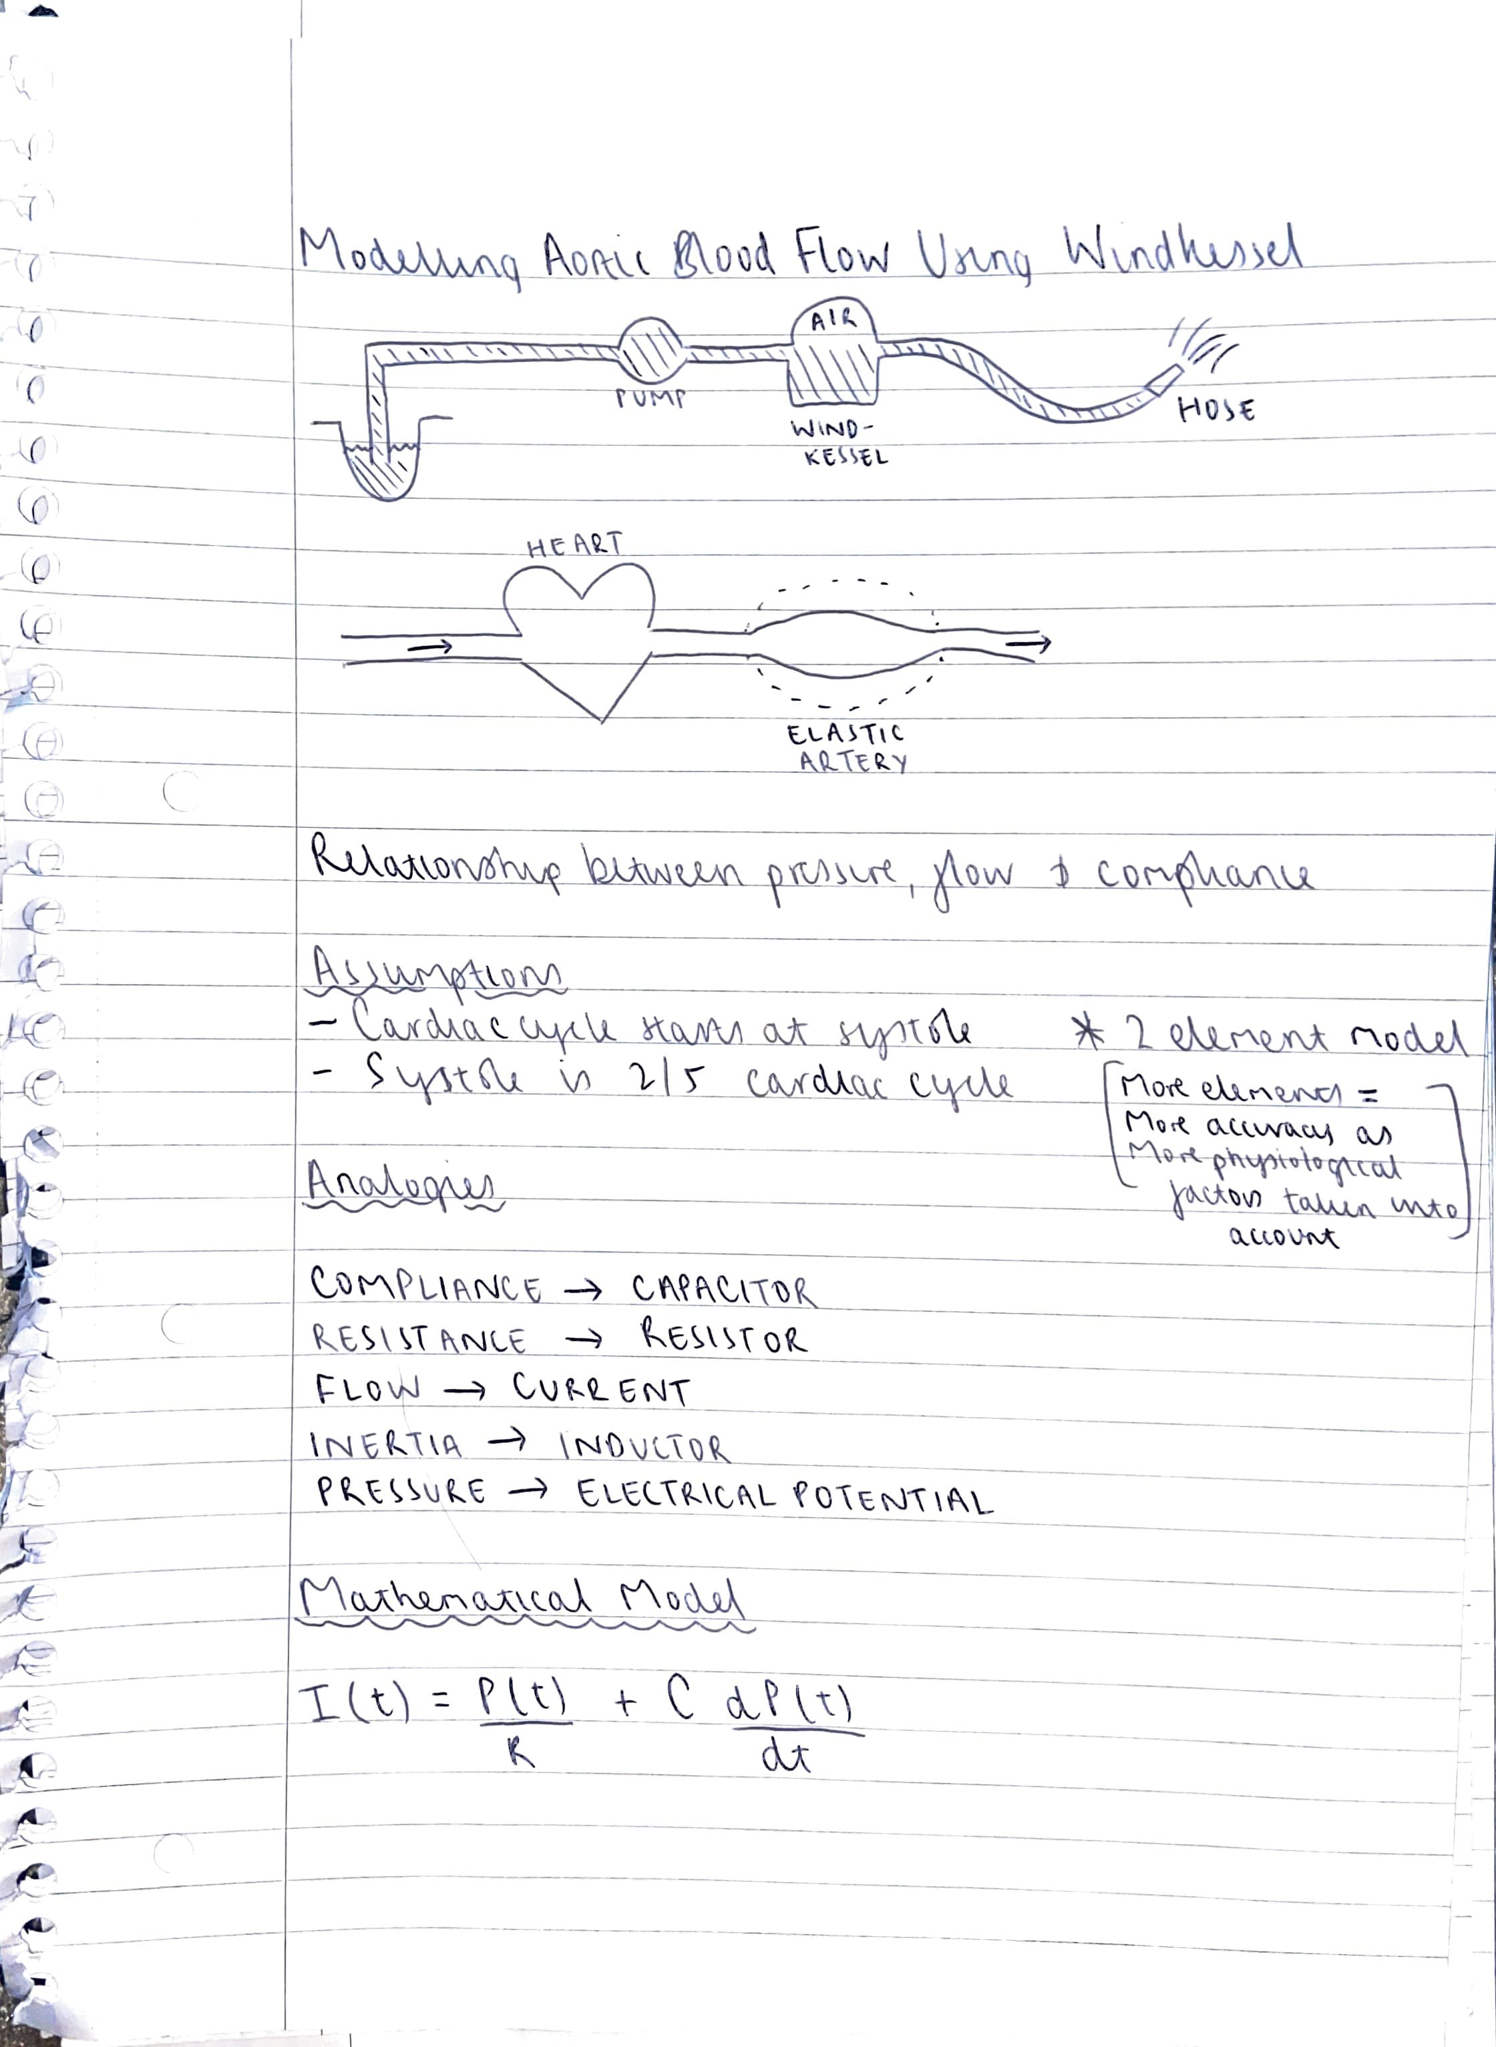

https://isn.ucsd.edu/courses/beng221/problems/2012/BENG221_Project%20-%20Catanho%20Sinha%20Vijayan.pdf

Above exemplifies the theory behind the Windkessel model and compares it to the human circulatory system. In investigating the relationship between the flow, pressure and compliance assumptions must be made. These include that the cardiac cycle starts at systole which is 2/5 of the cycle as a whole. This makes diastole 3/5. Analogies are made in using this system and they are that compliance relates to capacitance in the electrical sense. Resistance does not change only now it relates to the opposition of blood flow. The flow itself is current. Inertia would be inductance if we were talking about an element model greater than 2. Lastly pressure is electrical potential.

With regards to the element models. The more elements in a model, the more accurate due to the introduction of more physiological parameters to the model. However, this makes things much more complicated so a 2-element model was used.

The mathematical model is shown above aswell.

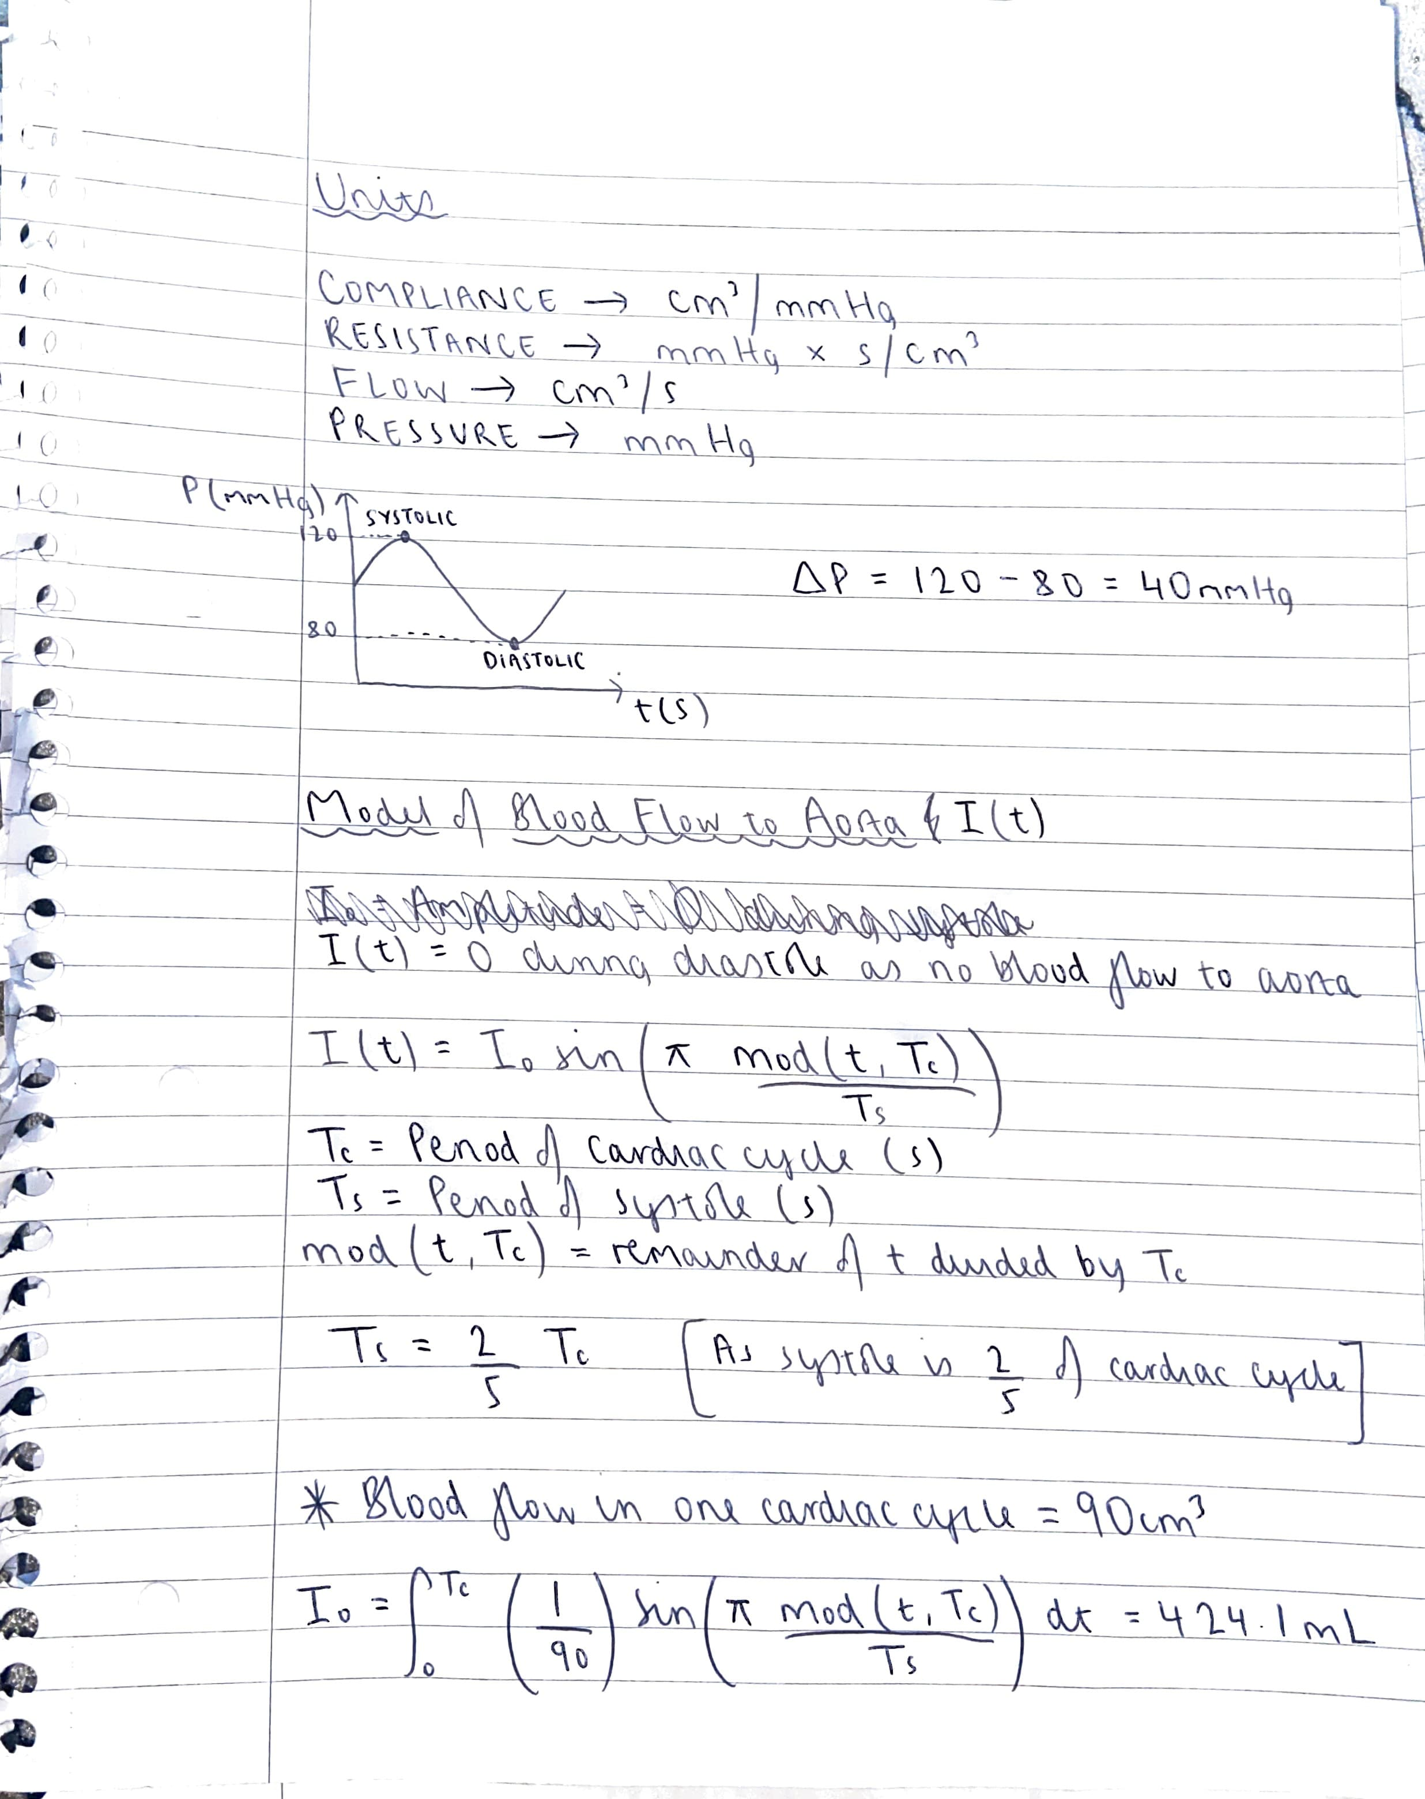

The units used for these parameters are shown also.

The relationship between pressure and time can be shown to be sinusoidal in nature. With the difference between the maximum and minimum being 40mmHg.

A model for blood flow in the aorta from the ventricle I(t) could then be investigated. And was represented by the equation shown and the amplitude was 424.1cm^3.

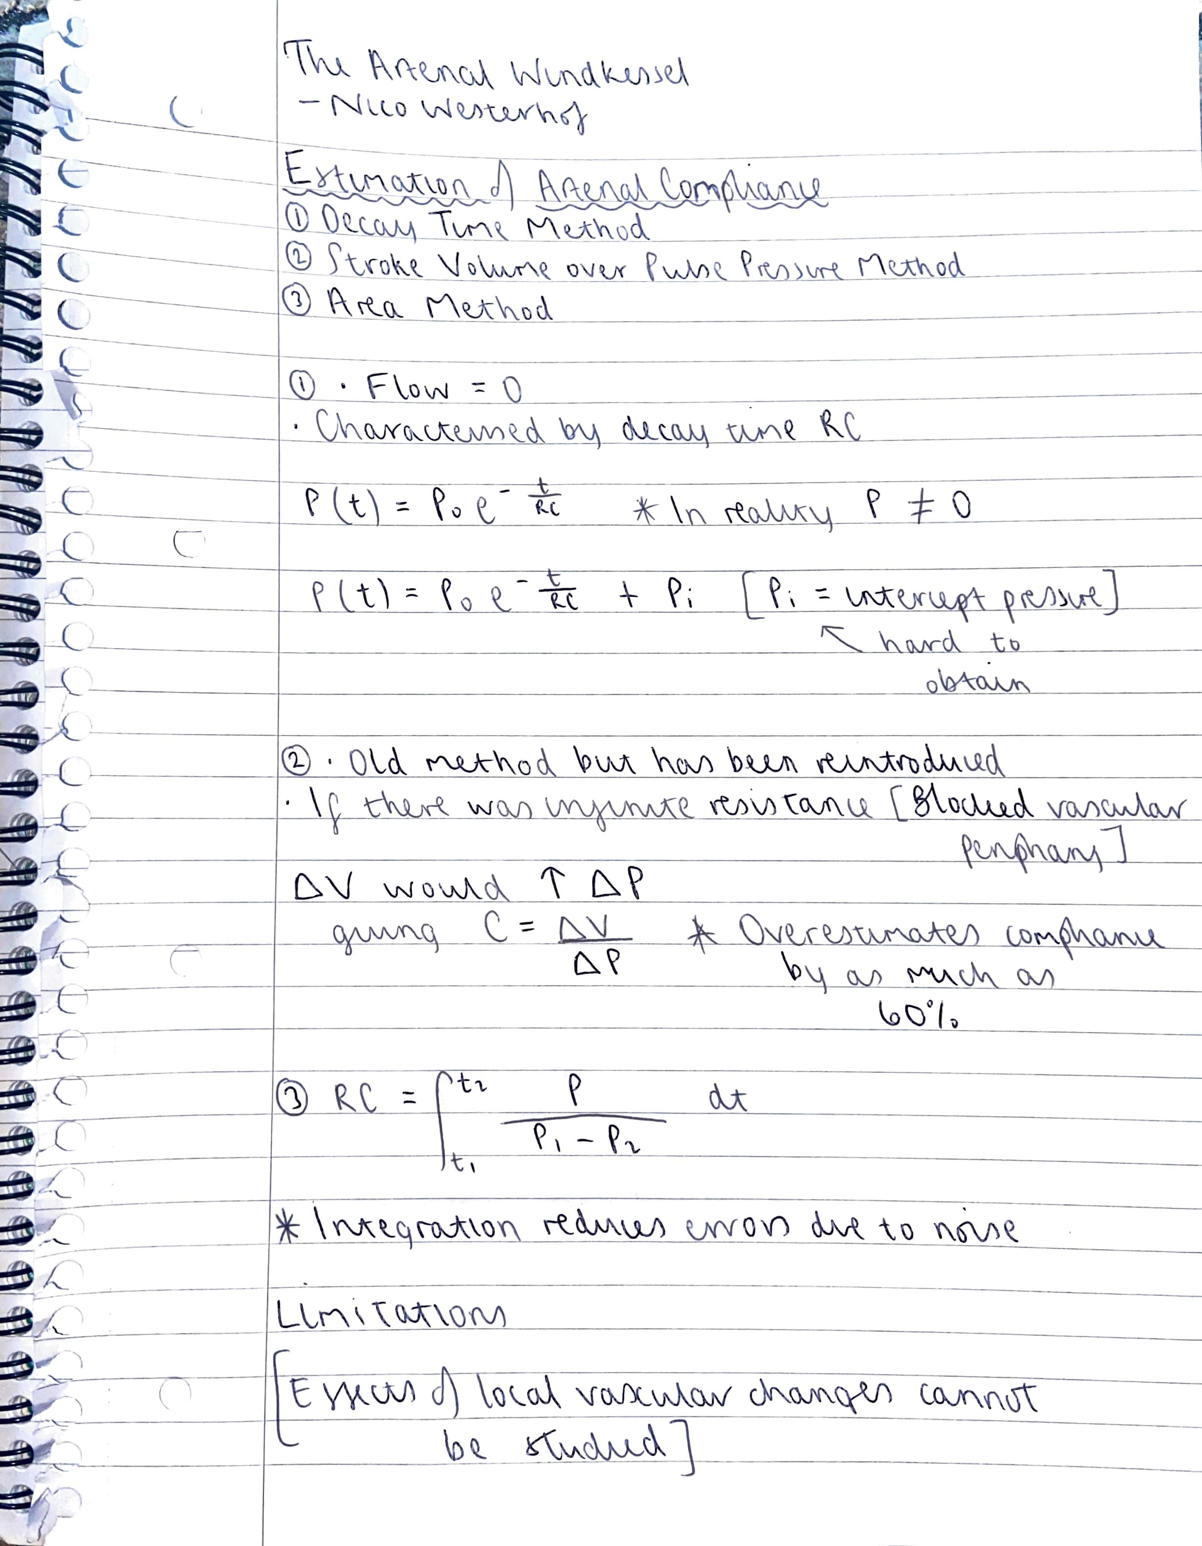

https://link.springer.com/article/10.1007/s11517-008-0359-2

Next a paper was researched into pertaining to ‘The Arterial Windkessel’. There were 3 methods shown to estimate arterial compliance. Including decay time, stroke volume over pulse pressure and lastly area methods. These all had their own inaccuracies including in the decay time method, intercept pressure being hard to obtain. In the pulse pressure method, there is an overestimation of compliance by as much as 60%. With the area method and the pulse pressure method being comparable, this puts them both in the same bracket being subject to great inaccuracies.

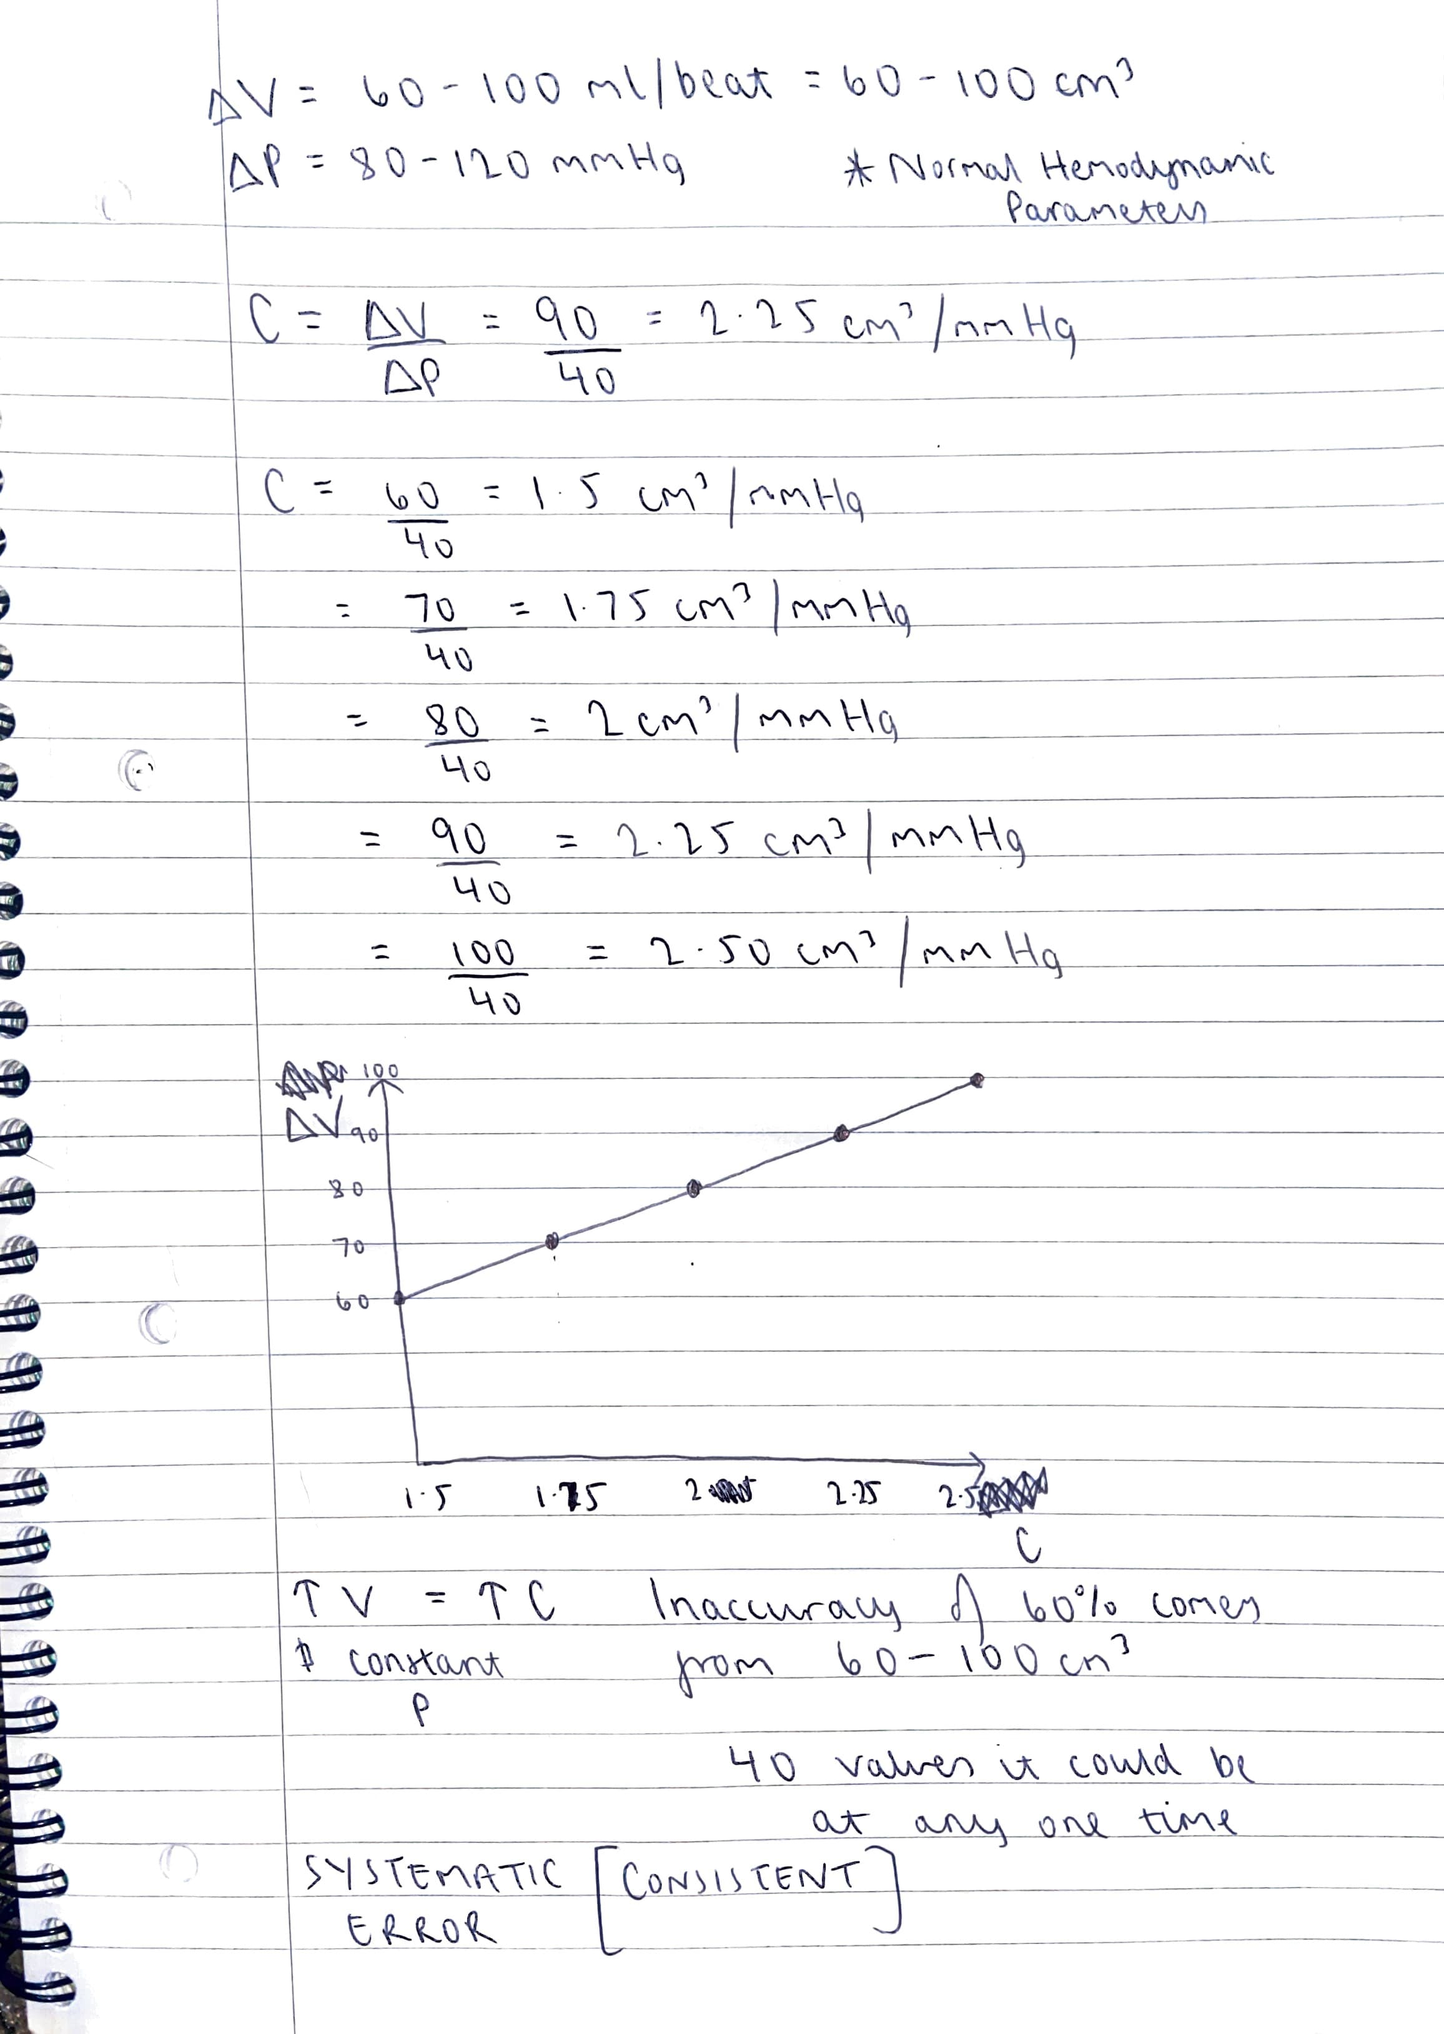

These inaccuracies were investigated using the pulse pressure method. The stroke volume was graphed against values of compliance when the pressure is assumed to be 40mmHg (Systolic – Diastolic) (120-80mmHg). We can see as the volume increases so does the compliance as the pressure is constant. Due to the gap seen in the y-axis, we can see there is a systematic error. This type of error will never disappear no matter how many times an experiment is repeated. So, using this method it will always be consistently off by 60%.

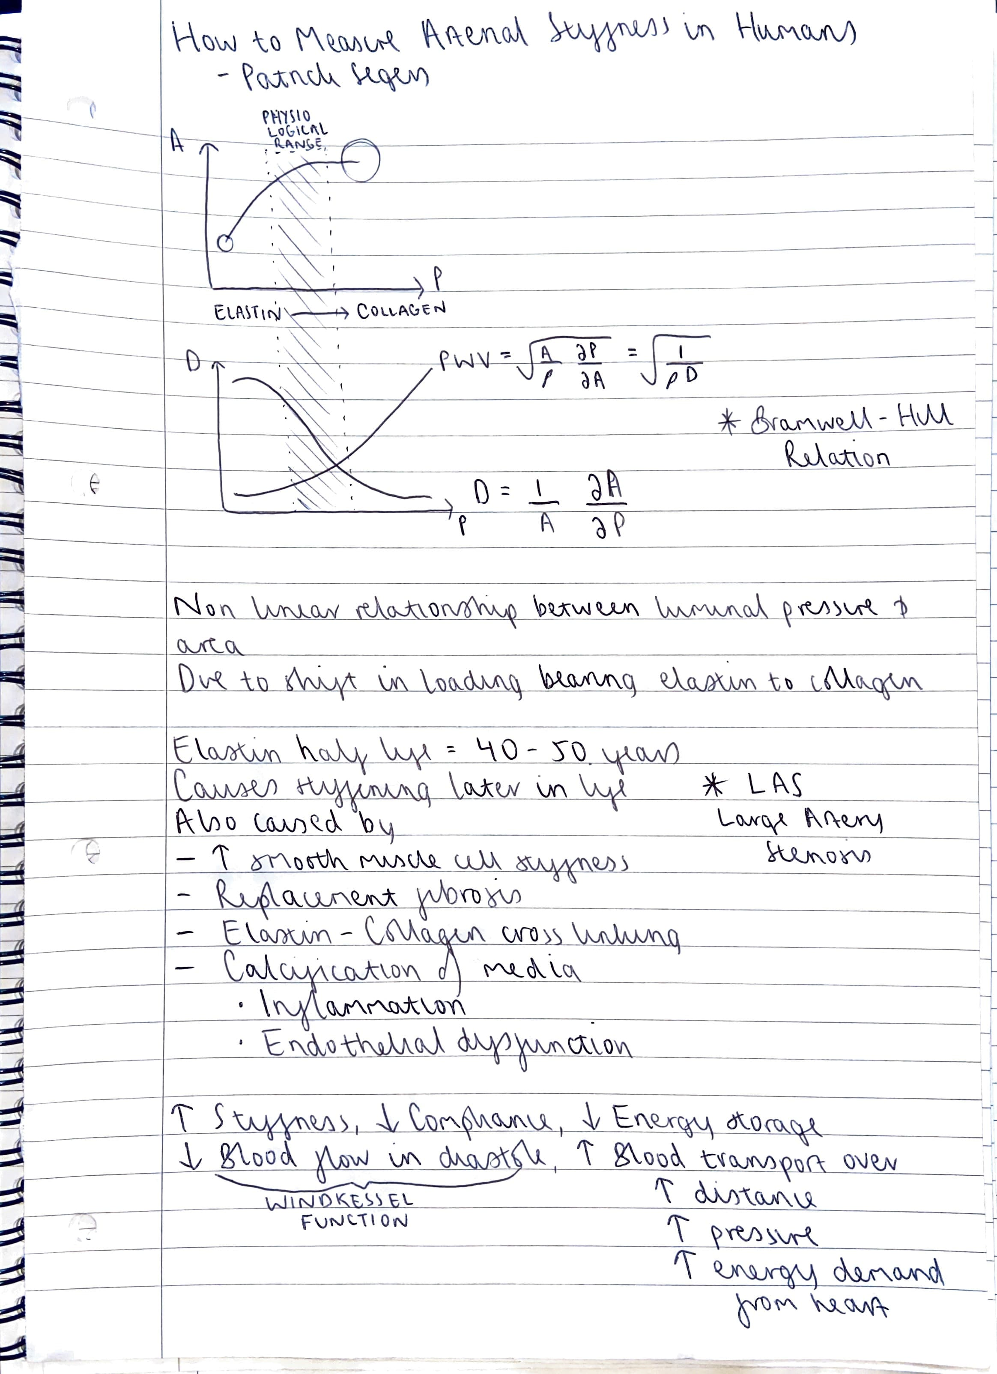

https://www.ahajournals.org/doi/10.1161/ATVBAHA.119.313132

Further research was then done into just how arterial stiffness could be calculated and the possible methods. The first graph plots area against pressure. As area increases we can see so does the pressure. The circles in the graph are just a visualisation of artery diameter. We can also see aswell that as the arterial area increases so does the progression of elastin into collagen.

The second graph plots distensibility (stiffness) against pressure. There are curves plotted for pulse wave velocity and distensibility. Pulse wave velocity is the velocity at which the pulse pressure wave propagates along a length of artery. Measured in ms-1. There are two ways to calculate this as shown above. One using the distensibility and the other can be done without. This is called the Bramwell-Hill Relation.

Distensibility equation is also shown above. Its units are the same as compliance cm^3/mmHg.

We can see a non linear relationship between luminal pressure and area.

This is due to shift in load bearing elastin to collagen.

The theory behind why stiffness occurs in older individuals stems from elastin’s half-life being around 40-50 years and bad lifestyle choices can further accelerate this.

In essence an increase in stiffness makes a vessel less compliant. This decreases the ability for energy storage. Blood flow in diastole also decreases. Blood will then need to be transported over a greater distance meaning a greater pressure requirement. This in turn means greater energy demand from the heart.

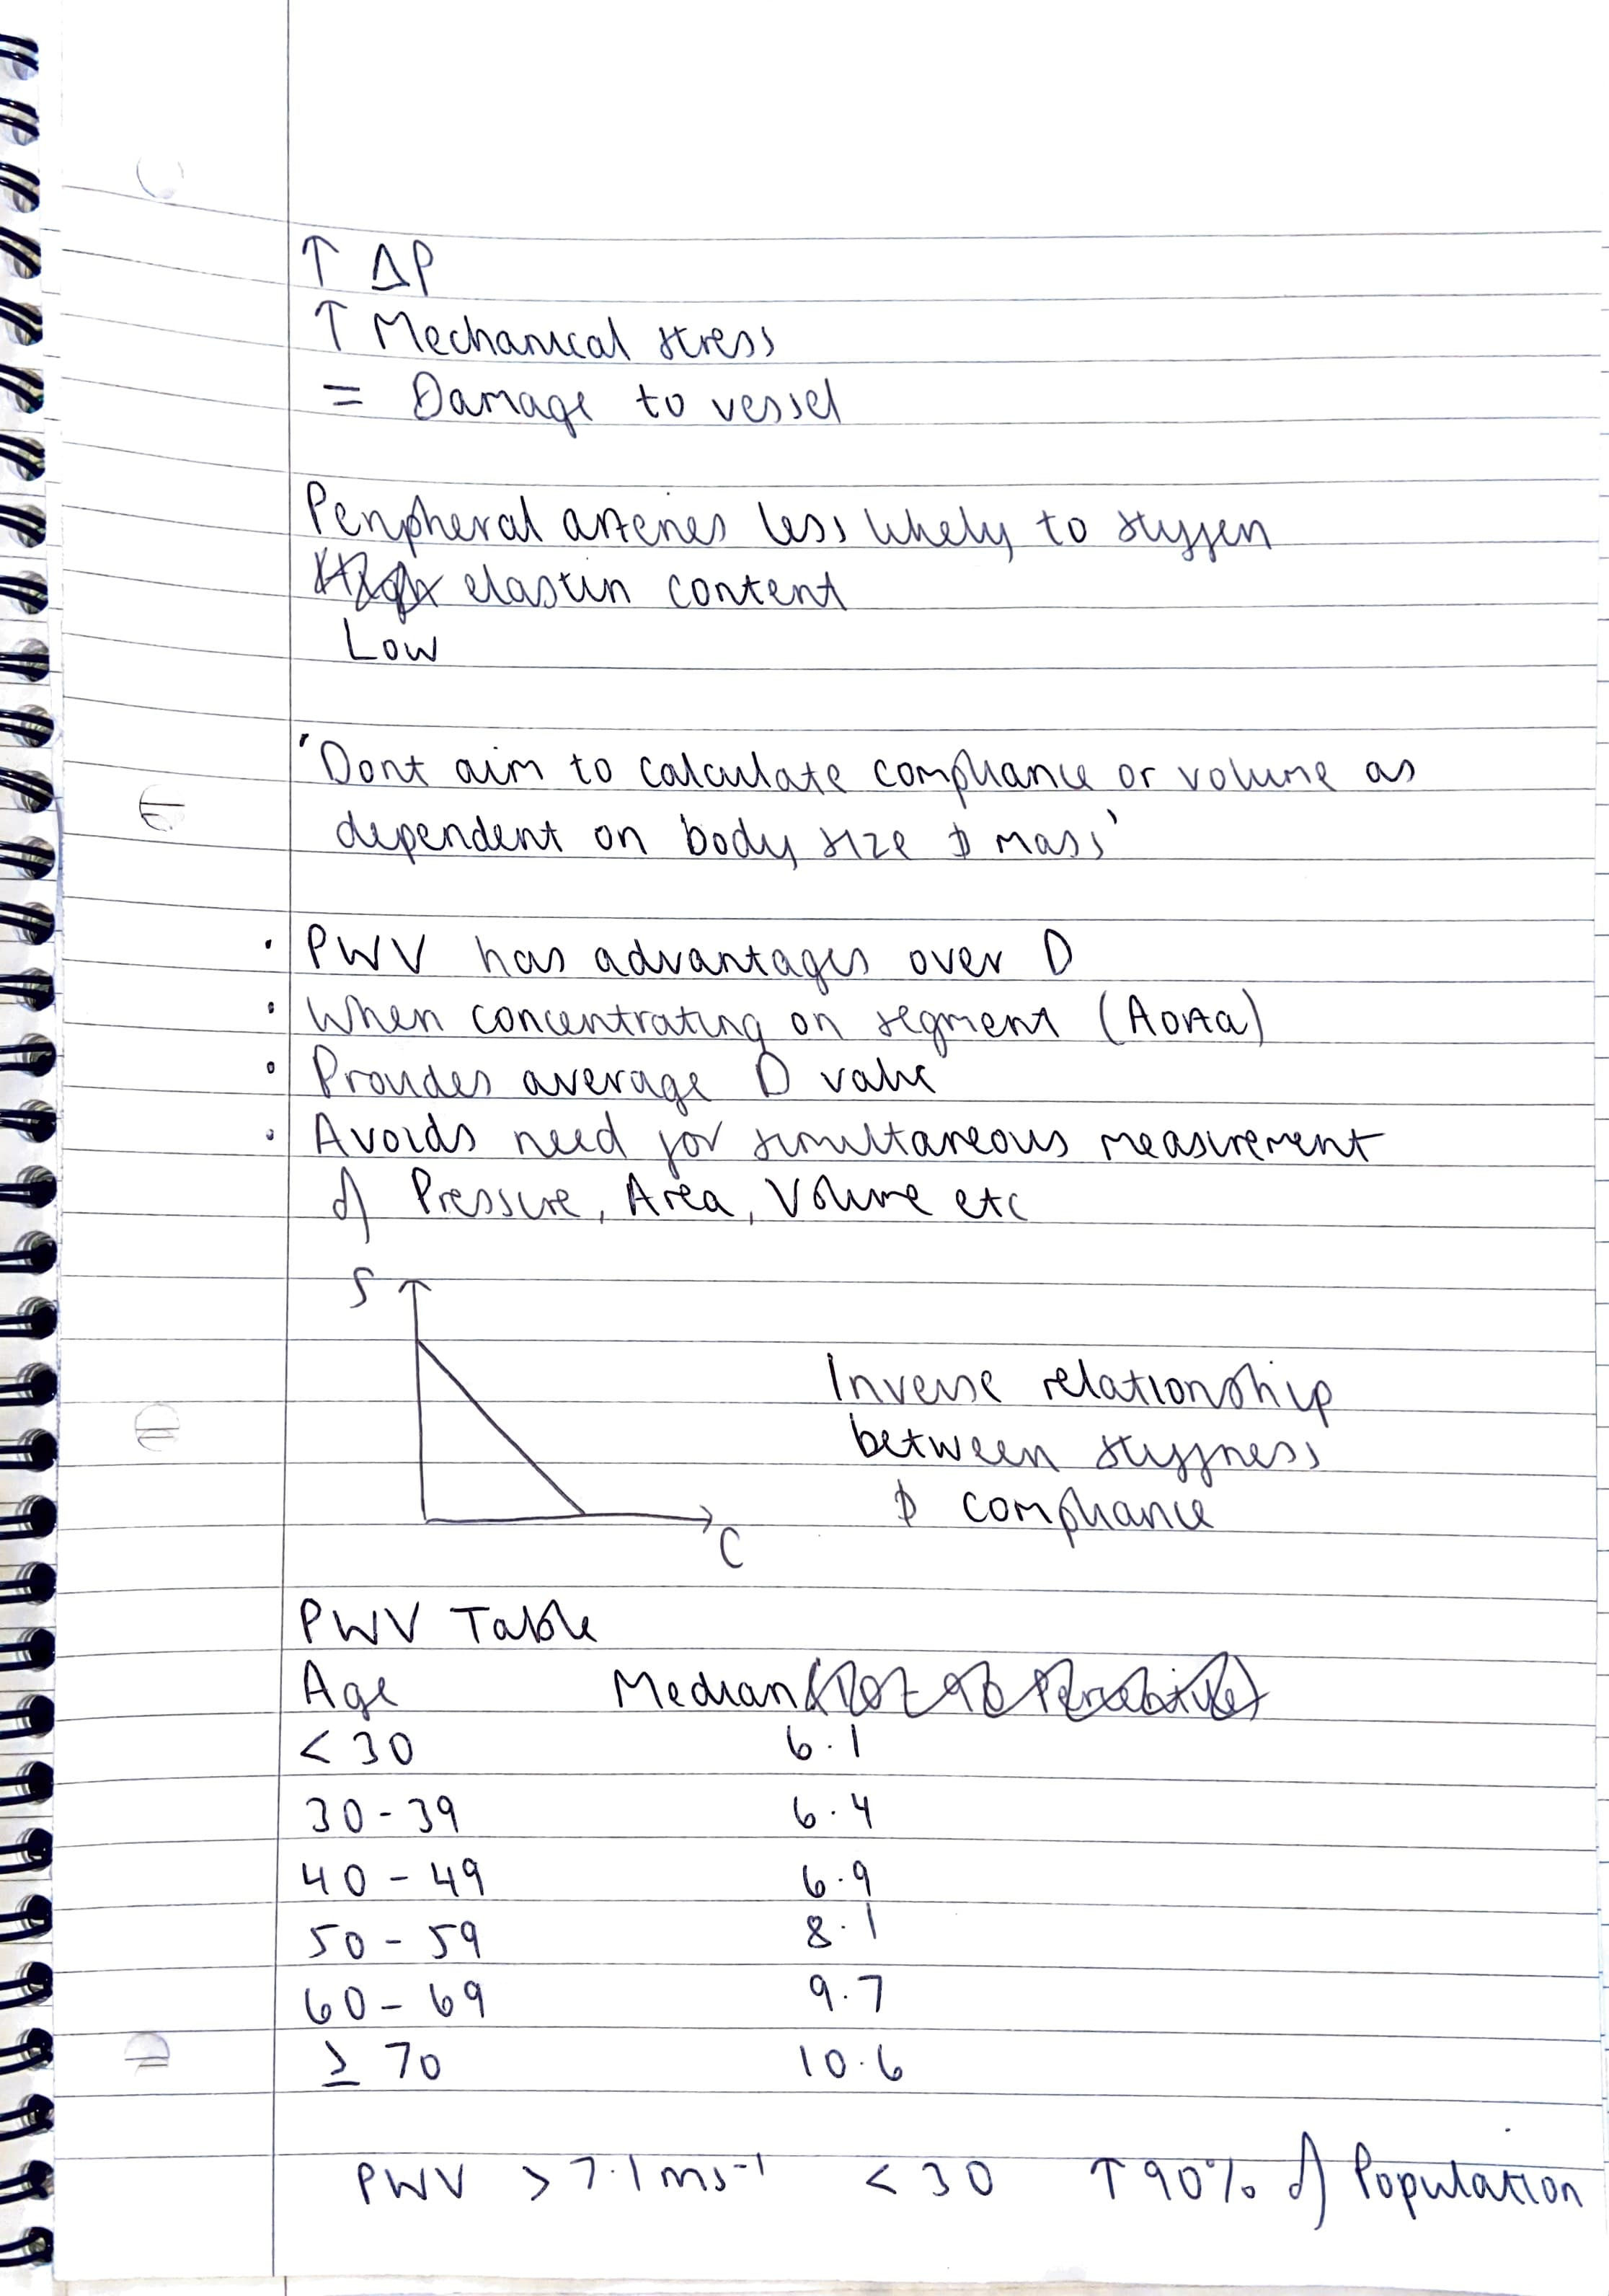

This large pressure difference will increase the mechanical stress on the heart and vessels. Causing damage to the vessel and the endothelial cellular level.

Peripheral arteries are less likely to stiffen due to their low elastin content.

This paper overall did not aim to calculate compliance or volume, as these are dependent on body size and mass.

However, finding this out using the PWV has advantages over distensibility.

In concentrating on an area like the aorta. This provides an average distensibility value. Avoids the need for simultaneous measurement of factors like pressure, area, volume etc.

Table provided for values of age against median PWV value.

‘Vascular compliance defines how the amount of blood and the blood pressure in a specific vascular segment are related. The amount of blood is measured in terms of its volume- which can effect the blood pressure. Thus, the product of this measurement allows one to understand the compliance of the specific vascular segment. On the other hand, distensibility measures how much stress is being put on the wall of a certain blood vessel. The greater the distensibility, the greater the swelling occur in an artery due to blood pressure.’

Thus compliance and distensibility can be related and calculated using a much more accurate method as opposed to Windkessel.

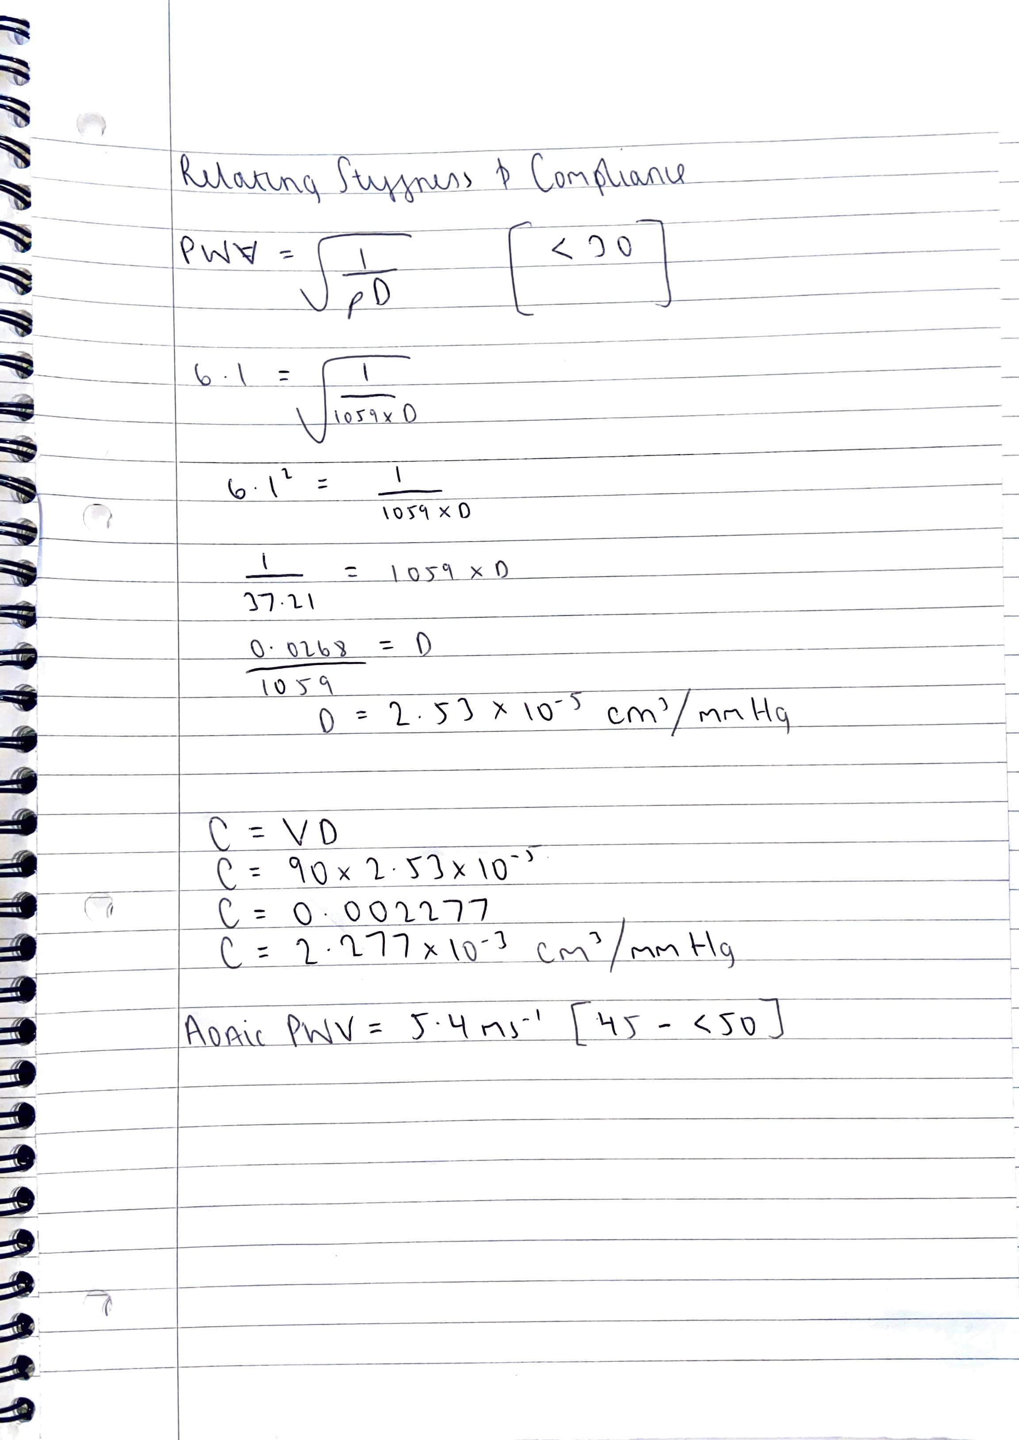

References

<https://isn.ucsd.edu/courses/beng221/problems/2012/BENG221_Project%20-%20Catanho%20Sinha%20Vijayan.pdf>

<https://link.springer.com/article/10.1007/s11517-008-0359-2#Sec5>

<https://pubmed.ncbi.nlm.nih.gov/29308546/>

<https://www.sciencedirect.com/topics/medicine-and-dentistry/artery-compliance/pdf>

<https://www.lidco.com/education/normal-hemodynamic-parameters/>

<https://www.youtube.com/watch?v=lIEBVmji1Co>

<https://support.withings.com/hc/en-us/articles/220037468-Body-Cardio-What-are-normal-values-for-Pulse-Wave-Velocity->

<https://www.ncbi.nlm.nih.gov/pmc/articles/PMC3312851/>

<https://www.ahajournals.org/doi/10.1161/01.HYP.26.3.531>

<https://jcmr-online.biomedcentral.com/articles/10.1186/s12968-019-0530-y>

<https://jcmr-online.biomedcentral.com/articles/10.1186/s12968-021-00739-y/tables/2>